DRC TECHNO
D-Imaging
USER MANUAL v 1.0
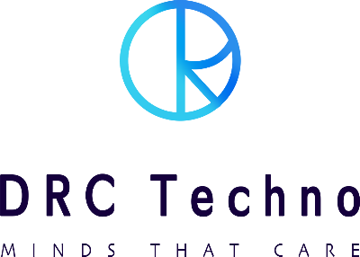

No. 1 choice
of Gem & Jewellery business owners.

CONFIDENTIAL
This information is the property of DRC Techno.
Any reproduction, publication or distribution to a third party is strictly forbidden
Thank you for choosing D-Imaging, a high tech camera for diamonds, assesses the 3Cs; clarity, cut and colour of a diamond in 3D. Witness the crystal clear magic which lies in the little cuts of the stones. With an advanced diamond photography system, D-Imaging has made it easier to view the diamonds inside out. It provides images as well as videos of diamonds. The machine scans all kinds of jewellery with 360-degree auto - rotate operation.

About Company
DRC Techno was founded in the year 2012 is a successful R&D and innovation company based in Surat, Gujarat, India. What makes us distinct is our key focus and attention on our customer values and satisfaction. Our dedicated engineers and developers are top-notch in their endeavour, giving customers the value for their money. We have fully functional labs for different types of prototypes design and production. From manufacturing to retail, we support and strengthen the diamond industry at every stage of the supply chain by providing low cost, high-value, scalable solutions, integrating technology and business innovation alongside efficient customer support.

DRC Techno is an organization with a social touch actively engaged in research and development of techno-commercial solutions for trade, industries and society at large. Alongside participating & engaging into activities that ensure the access to education for children who are marginalized or deprived of their basic right to quality education and empowerment.

Table of Contents

1. Safety First ……………………………………………………………………………………………………………………………………….. 3
1.1 Symbol definitions ……………………………………………………………………………………………………………………… 3
2. System Requirement & Specification ……………………………………………………………………………………………….. 4
2.1 Power Supply ……………………………………………………………………………………………………………………………… 4
3. Camera & Computer System ……………………………………………………………………………………………………………. 5
3.1 Camera & accessories ………………………………………………………………………………………………………………… 5
3.2 Computer System ………………………………………………………………………………………………………………………. 6
4. Device description …………………………………………………………………………………………………………………………… 7
5. Accessories ………………………………………………………………………………………………………………………………………. 8
6. Device Installation ………………………………………………………………………………………………………………………….. 10
7. Device operating instructions …………………………………………………………………………………………………………. 10
7.1 Click Movie/Image ……………………………………………………………………………………………………………………. 11
7.2 Crop Settings ……………………………………………………………………………………………………………………………. 15
7.3 Rectangle Style …………………………………………………………………………………………………………………………. 16
7.4 Rotation …………………………………………………………………………………………………………………………………… 17
7.5 Light/Camera Profile ………………………………………………………………………………………………………………… 19
7.6 User …………………………………………………………………………………………………………………………………………. 22
8. Troubleshoot …………………………………………………………………………………………………………………………………. 23
9. FAQ ……………………………………………………………………………………………………………………………………………….. 24
10. Warranty ……………………………………………………………………………………………………………………………………… 25
10.1 Limited Warranty …………………………………………………………………………………………………………………… 25
10.2 Exclusion ………………………………………………………………………………………………………………………………… 25
10.3 Warranty Claim Process …………………………………………………………………………………………………………. 26
10.4 Software License ……………………………………………………………………………………………………………………. 26
11. Terms and Conditions ………………………………………………………………………………………………………………….. 27
12. Caution (Laser Radiation) …………………………………………………………………………………………………………….. 33
13. Disclaimer ……………………………………………………………………………………………………………………………………. 33
Notes …………………………………………………………………………………………………………………………………………………. 34

1. Safety First

At DRC Techno the safety of all individuals working with the equipment is important and recommends reading the safety information mentioned below before attempting to operate the system or perform any other process. Failure to observe these instructions can lead to injury or damage to the Device.

1.1 Symbol definitions

- Observe and follow all written & sign warnings, and caution indicators given in this document.

- All the procedures of the machine should be performed by trained or authorized personnel only unless specified in the document.

No. | Symbol | Description
1. |  | This symbol indicates a possible damage or loss of data that may have occur and cause permanent loss of the device if handled by an unauthorized person.
2. | 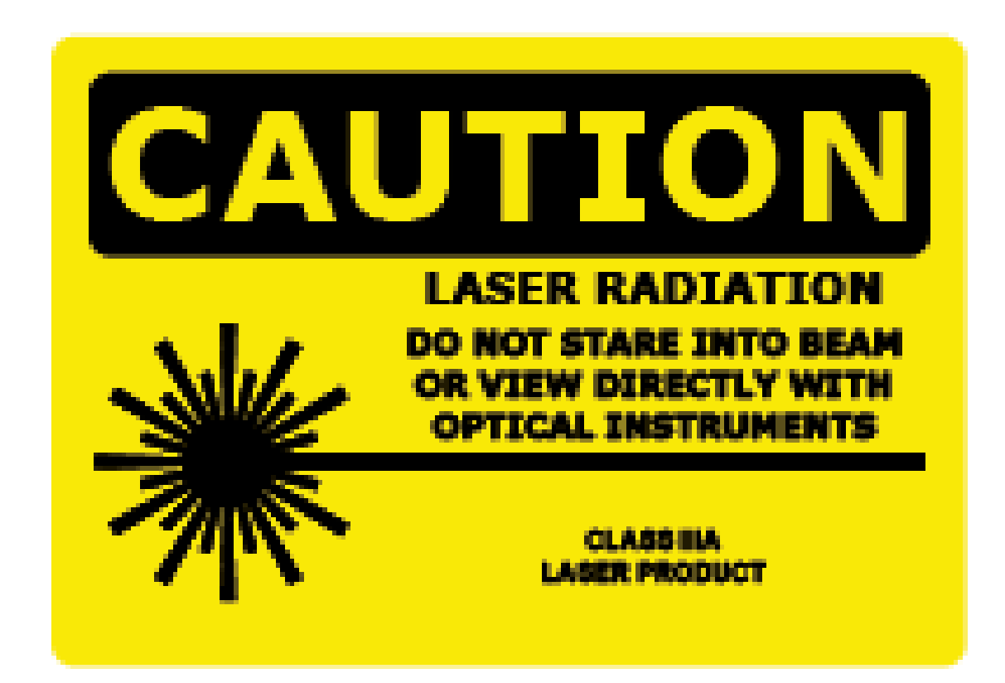 | This symbol indicates the rays of invisible laser radiation.  Avoid exposing your eyes and skin to direct or scattered radiation. Proper eye and skin protection required.
3. |  | To reduce the risk of electric shock or damage to the equipment:  - Do not disable the power cord grounding plug, it is an important safety feature.  - Plug the power cord into a grounded (earthed) electrical outlet that is easily accessible at all times.  - Unplug the power cord from the power supply to disconnect power to the equipment.  Place the power cord where it is not damaged by or pressed by items placed near it. Pay attention to the plug, electrical outlet, and the point where the cord extends to the server.

2. Device Specification

M/c | Size(mm) | Weight (kg)
D-Imaging | 220 x 662 x 245 | 13.12
Vacuum Pump | 106 x 161 x 122 | 2.3

2.1 Power Supply

- Input Voltage Range: 230 V AC
- Input Current>= 3A
- Operating AC Frequency Range: 50 Hz
- Typical Response Time< = 5 s
- Temperature Range: 5 to 35 °C

3. Camera & Computer System
Supply of Computer system, Steam Cleaner, Camera & its accessories are under customer’s scope and for the same OEM is liable for the services. Following is the list/requirements

3.1 Camera & accessories

 | Description | Manufacturer
Camera | Camera Canon – 6D Mark II DSLR (Body Only) | Canon
 | - | -
 | Adapter Kit - ACK-E6 for above camera | Canon
 | Lens - EF-100mm,F2.8 L Macro USM | Canon

3.2 Computer System

System | Description | Manufacturer
Processor | Intel® Core™ i7-4790,3.6 GHz Processor (8M Cache, LGA1150), or Higher | Intel or Any Standard company made
RAM | 8GB DDR3 RAM | Any Standard company made
Graphic-card | 2 GB or Higher Graphics Card | NVidia or Any Standard company made
Operating system | 64 Bit Windows 7 Professional & above | Microsoft Window
Peripheral  Connections | 3 USB & 1 HDMI | Any Standard company made
Hard-drive | 500 GB SATA | Any Standard company made
Monitor | 21.5-inch Diagonal IPS LED Backlit Full HD Monitor Or advance preferred DELL | Any Standard company made
Peripherals | Mouse & Key Boards | Any Standard company made
Cabinet |  | Any Standard company made

- Internal Network access with Internet connectivity
- Without any IT restriction1
- Two active HDD partition C: and D:
- Software Installed - Win-zip, Ammyy Admin, Team Viewer, MS-Office
- Internet Browsers- Google Chrome, Mozilla Firefox

4. Device Description

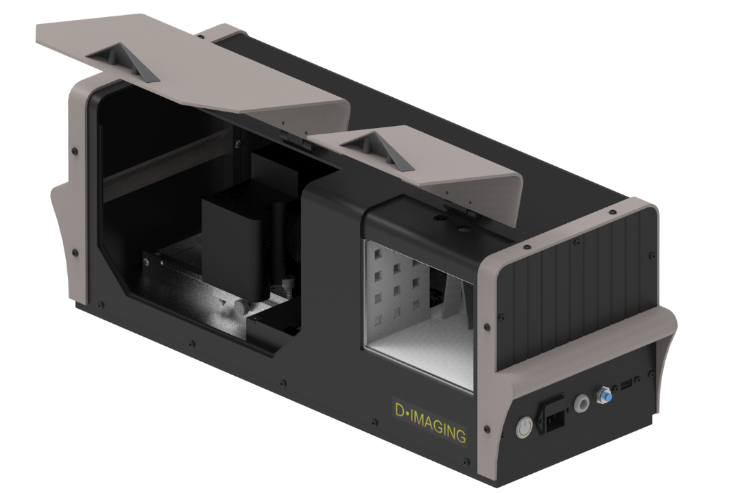
Diamond Stage
Camera Mount
Power Button
Vacuum Pump Socket
Power Cable
USB Port

5. Accessories

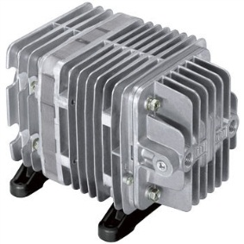

Vacuum Pump

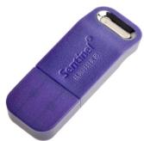

Software Key

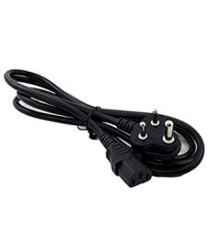

Power Cable

USB Cable
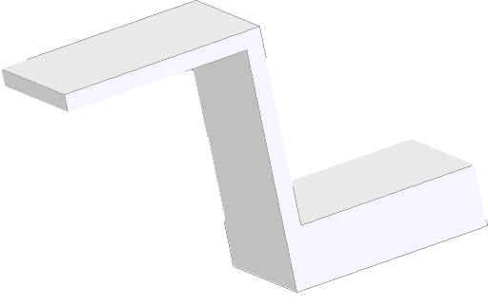
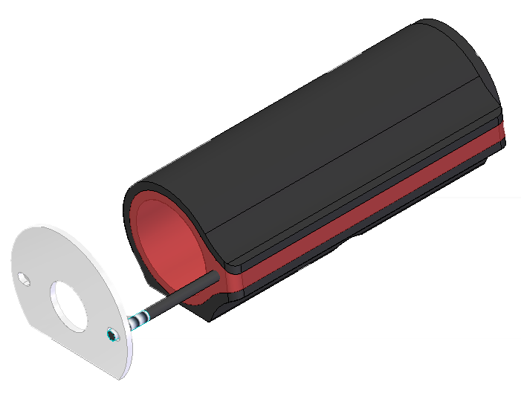
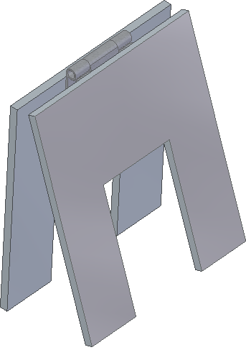
Reflector-Stand-DR

Background-Stand-DR

ASM-reflector-ACR-stand
stand

Loop

6. Device Installation

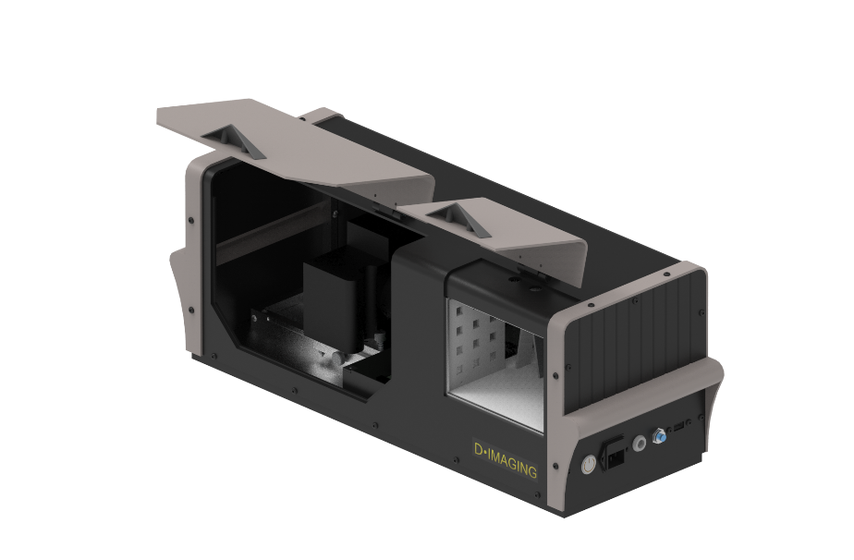

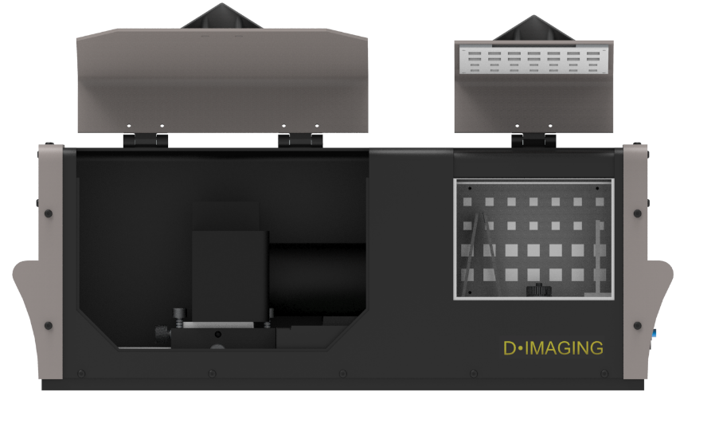
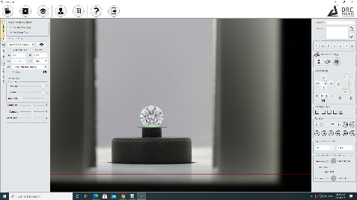
7. Device operating instructions
2. Place the camera (need to purchase separately) on the camera mount and also place the diamond on the stage along with the reflectors.

3. Connect the PC (need to purchase separately) to the machine, power on the PC and start the software.

1. Connect power cord & Vacuum Pump and switch on power.

- Switch on the “Instrument” and “Computer System”
- Start the Software and wait for the machine to load. Kindly confirm all hardware peripherals (Camera, Motor, Vacuum etc.) detected completely and displaying in software.

- Put the diamond inside the Machine and close the door

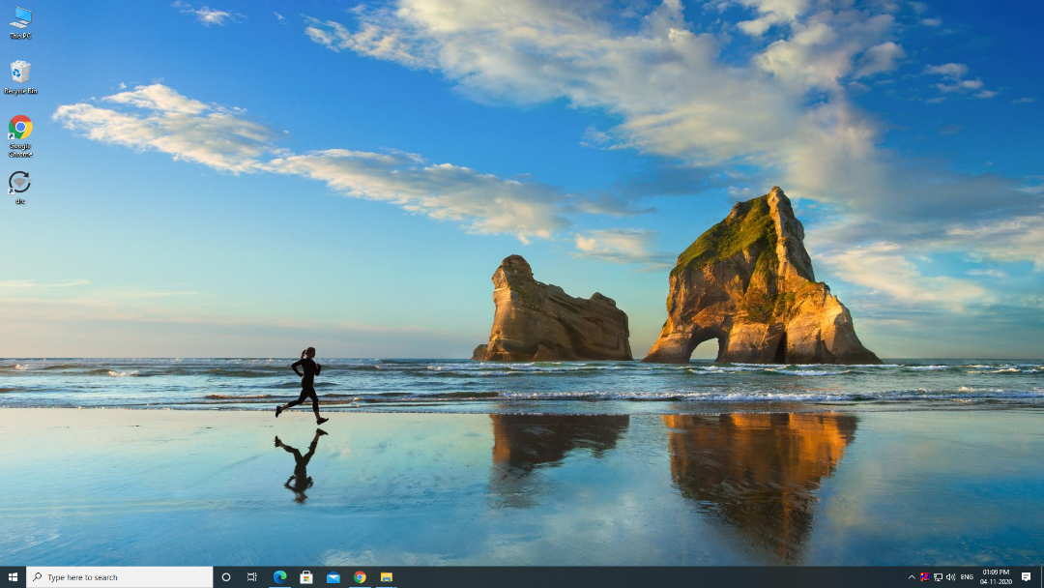

7.1 Click Movie/Image

- Click on Camera Preview Icon for a live view.
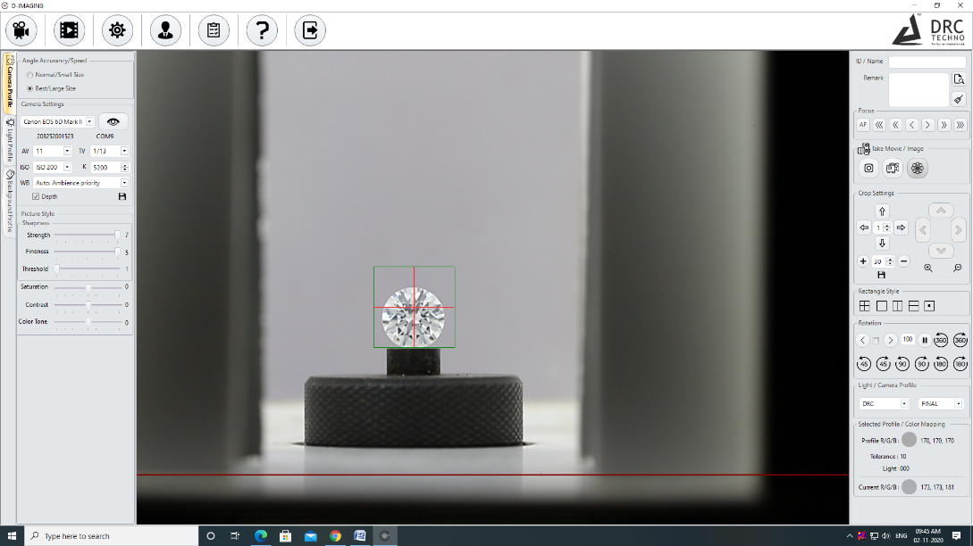

- Double click on the live Camera Viewer to Zoom the Camera.
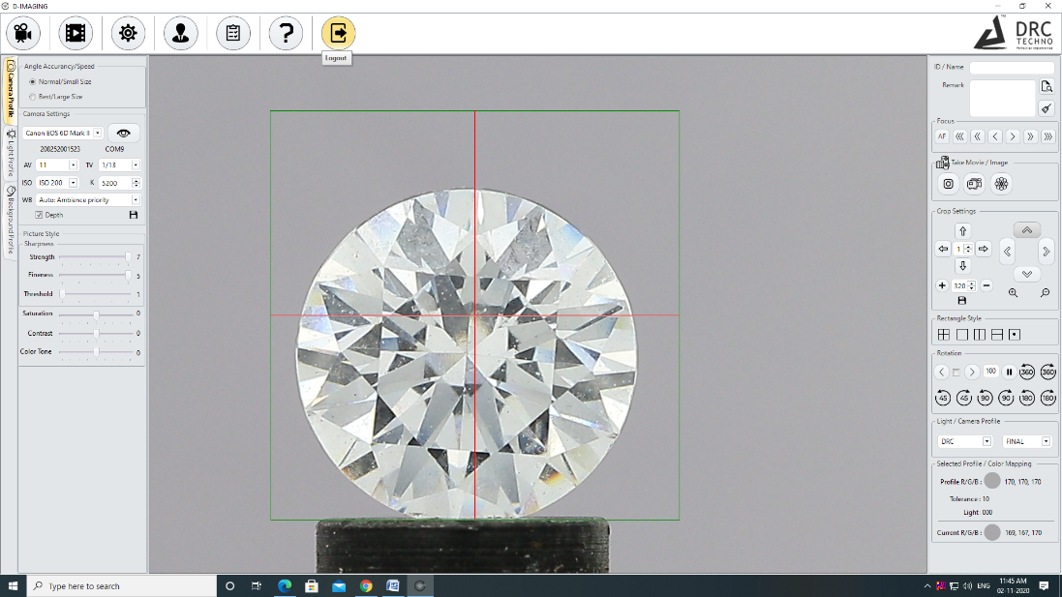

- Click on Auto focus Icon to adjust the focus of Camera automatically.
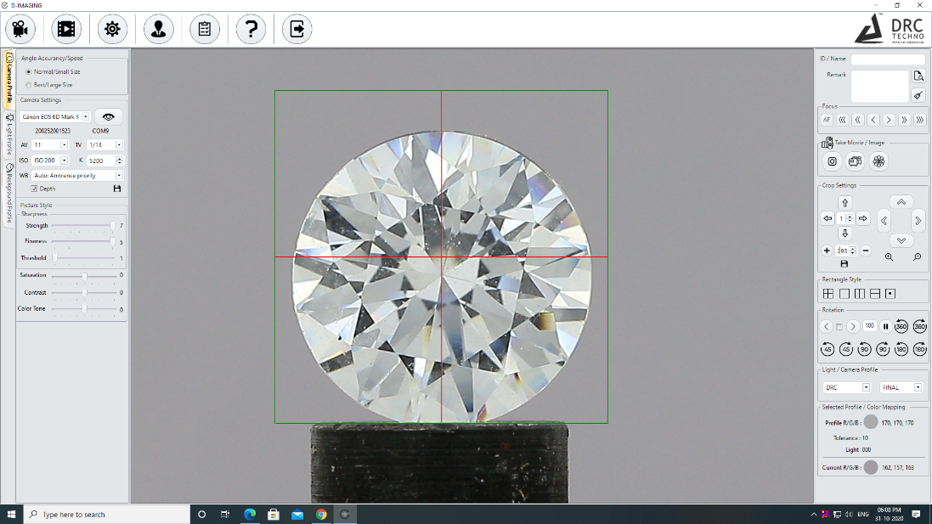

- Click on any of the below icon to focus manually.

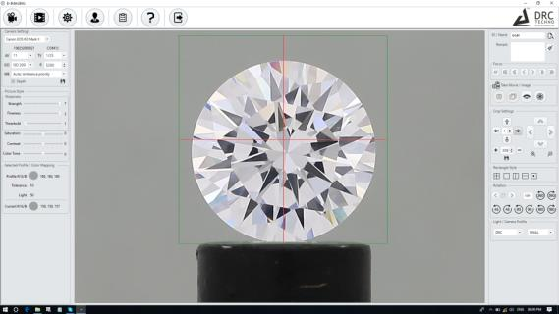

- After clicking the image, an icon will display with multiple options. Select any one from the displayed option and click on the Single Photo Icon to save the image of the Diamond.
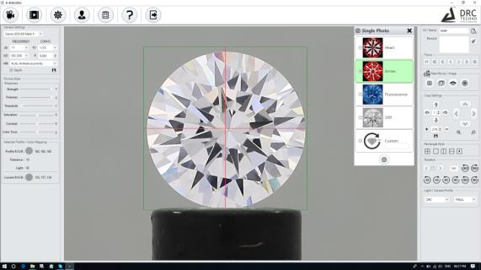

- Click on the Preview Icon for a Preview of the Image (Inside rectangle).

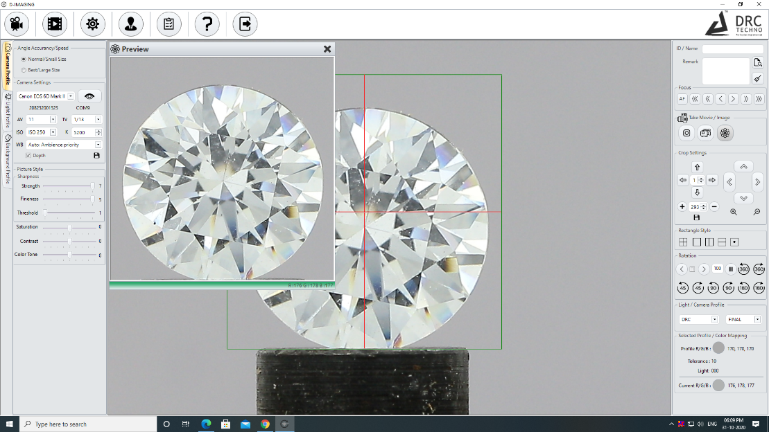

- Click on the Start Video button to start recording of the diamond.
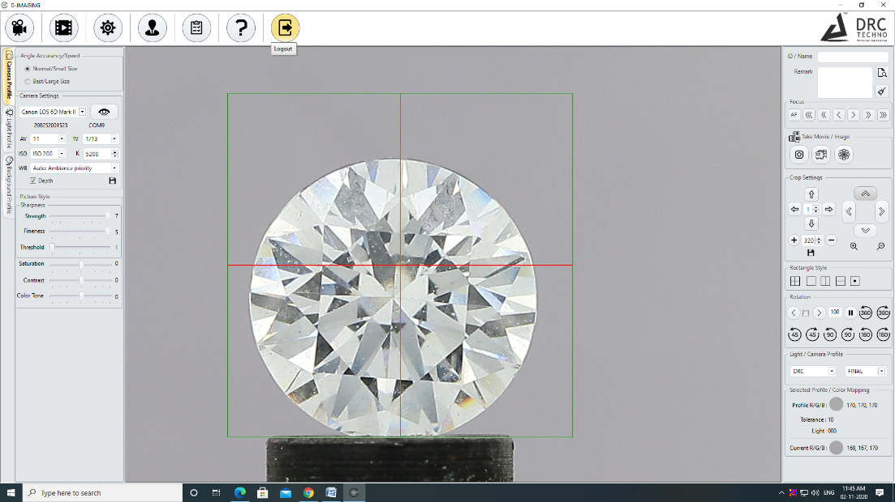

7.2 Crop Settings

- Click on the up, down, left, right arrows respectively to move the rectangle on any of the sides

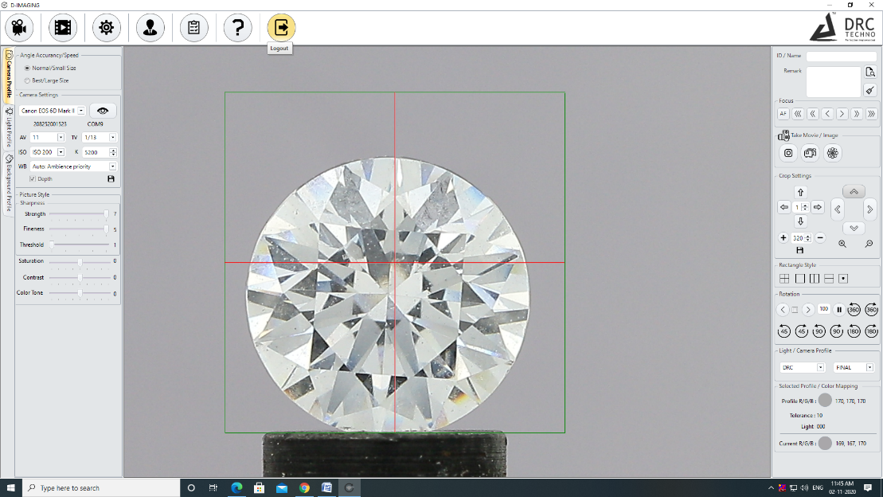

- To increase or decrease the speed of the rectangle displacement, change the value of Box inside the Arrow.

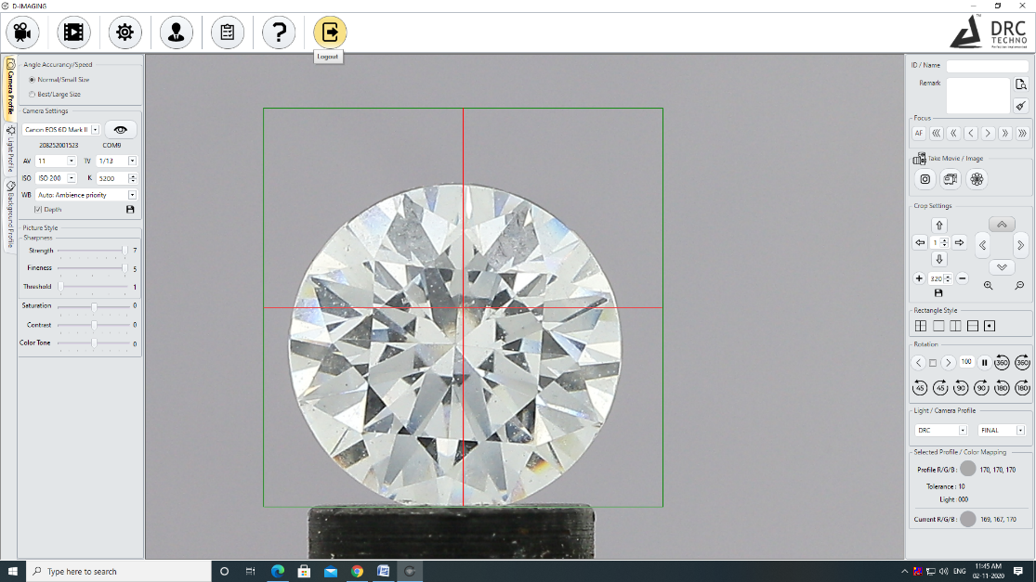

- Click on the Save Icon to save current value of the size of the rectangle.

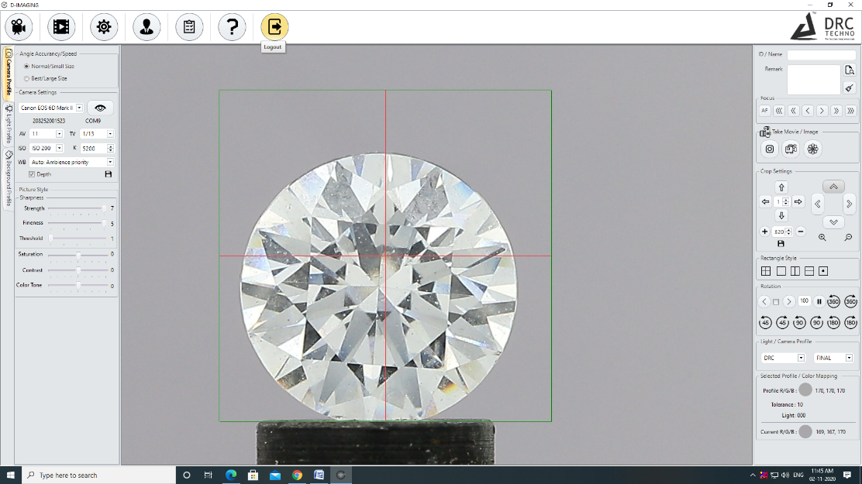

7.3 Rectangle Style

- To change the style of the rectangle, click on different icons as shown below

7.4 Rotation

- Click on the arrow Icon to Rotate the Diamond clockwise or anticlockwise.

- Click on 360⁰ clockwise or anticlockwise Icon to rotate Diamond in the desired degree
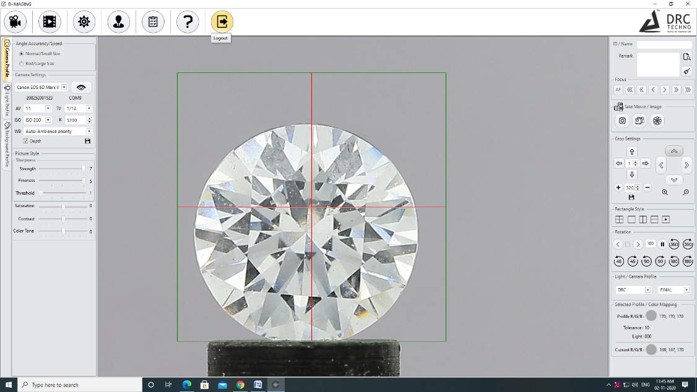

- Click on 45 clockwise or anticlockwise Icon to rotate Diamond 45⁰

- Click on 90 clockwise or anticlockwise Icon to rotate Diamond 90⁰
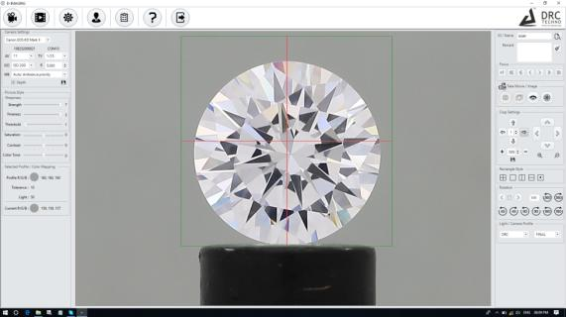

7.5 Light/Camera Profile

- To view the Heart and Arrow of the Diamond select H&A Setting from the Light/Camera Profile Region Then Rotate the Diamond.

- Click on Show Image Icon to play the Recorded Videos.

- Click on Search by Date or Name by clicking on Search icon to show the Recorded Videos.
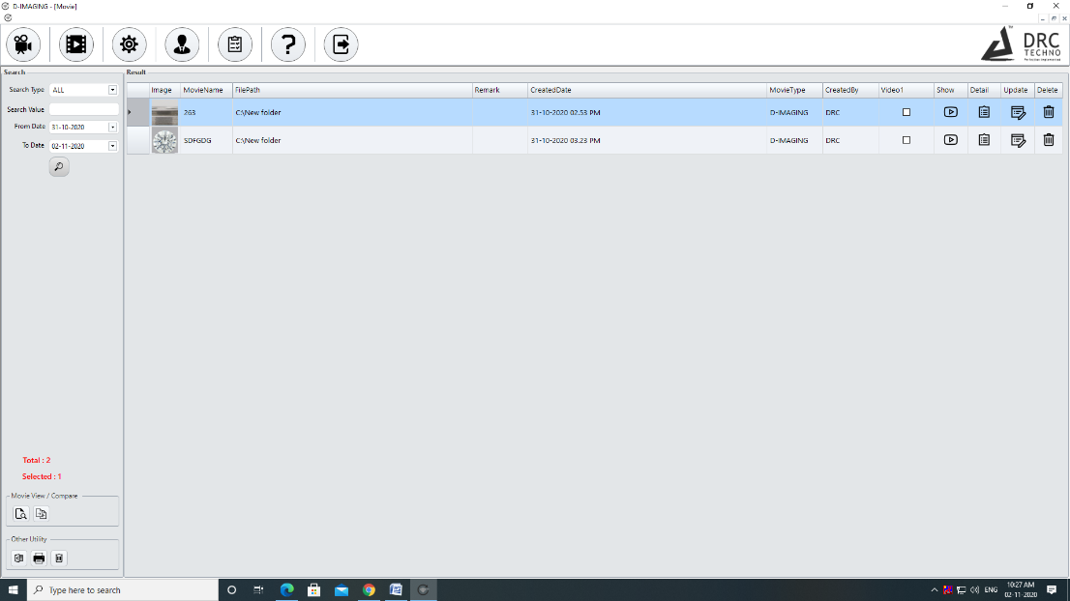

- Click on the Show Video Icon to Play the Video on D-Imaging Viewer (Browser).
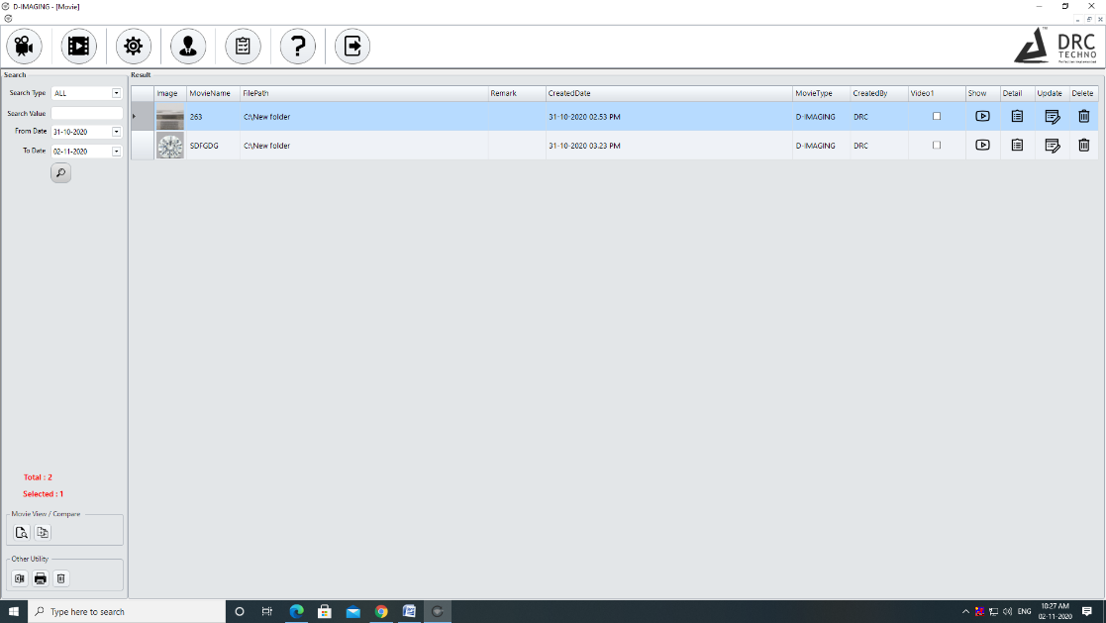

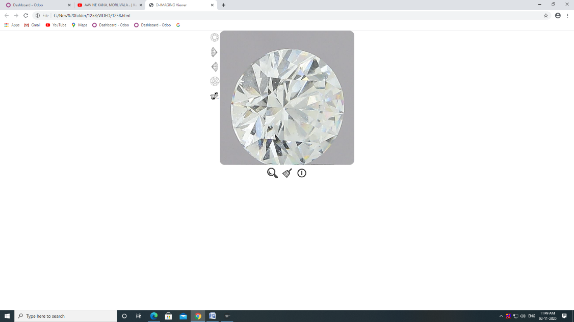

7.6 User

- Click on User Icon to show the login user Detail.

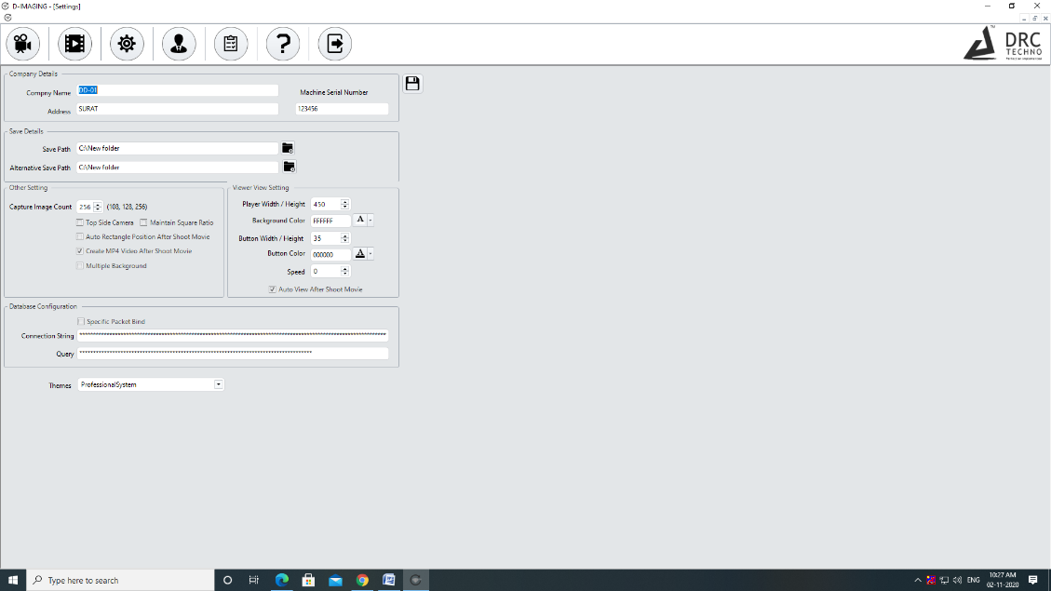

8. Troubleshoot

      - If the Machine is not working

- Plug in the right power supply as specified in the operation manual. Switch on the “Instrument” and “PC”.
- Start the software and wait until the machine gets initialized.

9. FAQ

What does D-Imaging do?

D-Imaging is used to capture all the impressive images of a diamond or a gemstone. It also includes a 360-degree video feature to capture all the parts of the diamond thoroughly and precisely.

How to operate?
Operating this device is very simple and easily understandable. The operator needs to go through the operation manual before operating D-Imaging.

How about after sales service?

While designing the machine, we have taken care of using limited parts that require service in the machine. If anything happens to the machine within the warranty period or even after the warranty period, the customer is advised to use the service centre of India. Soon we will be on-boarding an agency or a technician who can provide on-shore services in the country.

10. Warranty

10.1 Limited Warranty

Subject to the exclusions, limitations, and conditions set forth below, DRC Techno warrants to the original purchaser of the D-Imaging will be free from defects in material and workmanship, when subjected to normal, proper, and intended usage by properly trained and informed users, for twelve (12) months or 2000 hours from the date of shipment of the D-Imaging to the original purchaser (the “Warranty Period”).

DRC Techno SHALL NOT HAVE ANY LIABILITY IF THE D-Imaging (A) IS UNABLE TO DETERMINE, DISTINGUISH OR DETECT WHETHER AN ITEM BEING ANALYZED BY THE D-Imaging IS A NATURAL DIAMOND, POTENTIAL LABORATORY-GROWN, PROCESSED OR TREATED, OR POTENTIALLY A DIAMOND SIMULANT OR (B) MAKES AN INACCURATE DETERMINATION OR GIVES AN INACCURATE READING AS TO WHETHER THE ITEM IS A NATURAL DIAMOND, POTENTIALLY LABORATORY-GROWN, TREATED, OR PROCESSED, OR IS POTENTIALLY A DIAMOND SIMULANT.

For any defective D-Imaging that is returned to DRC Techno by the original purchaser during the Warranty Period in compliance with the process specified below, DRC Techno will, at DRC Techno's option, repair or replace the defective D-Imaging, or refund the price paid to DRC Techno for the defective D-Imaging. A replacement may be a new or refurbished D-Imaging in DRC Techno's sole discretion and any such replacement will continue to be subject to the warranty set forth above for the balance of the Warranty Period for the D-Imaging initially purchased.

10.2 Exclusion

D-Imaging will not be deemed defective and DRC Techno will not have any obligation to repair or replace a D-Imaging, or refund the price paid for the D-Imaging as a result of any one or more of the following: (I) normal wear and tear, (ii) accident, disaster, or event of force majeure, (iii) misuse, fault, or negligence of or by any user or other person, (iv) use of the D-Imaging in a manner for which it was not designed, (v) causes external to the D-Imaging such as, but not limited to, power failure, electrical power surges, exposure to fire, water, other liquids, excessive humidity or temperature, virus software attacks (vi) improper storage or handling of the D-Imaging, or (vii) use of the D-Imaging in combination with equipment or software not supplied by D-Imaging,

Opening or tampering the D-Imaging without the supervision of DRC Techno engineer or written approval of DRC Techno shall immediately void and cancel all warranties.

10.3 Warranty Claim Process

If the original purchaser of the D-Imaging believes that the D-Imaging is defective, then the original purchaser will promptly contact DRC Techno Warranty or Customer Service at +91 9909990867 or Support@drctechno.com. The original purchaser will provide to the DRC Techno customer service representative the product model and serial number, the date of purchase, and details of the alleged defect. In addition, if requested by the DRC Techno customer service representative, the original purchaser will also provide to DRC Techno customer service representative additional information regarding the alleged defect and the use of the D-Imaging. DRC Techno will review the information provided by the original purchaser to confirm that the Warranty Period has not yet expired, and (c) DRC Techno's belief that the D-Imaging is likely defective, DRC Techno will guide the further steps to the original purchaser.

10.4 Software License

DRC Techno hereby grants to the original purchaser of the D-Imaging a non-exclusive, non-transferable license, without the right to sublicense, to use the software embedded in the D-Imaging (the “Software”) solely with the D-Imaging and solely for the purpose for which it was designed, and not for any other purpose. This license terminates when the owner of the D-Imaging ceases to possess the D-Imaging (including without limitation upon the transfer or sale of the D-Imaging to a third party). No license is granted and no person or entity has the right to sell, transfer, license, loan or otherwise make available in any form to third parties the Software other than the transfer of the Software to the purchaser or transferee of the applicable D-Imaging. No owner of the D-Imaging may disassemble, decompile or reverse engineer, copy, modify, enhance, or otherwise change or supplement the Software without DRC Techno's prior written consent. DRC Techno retains all right, title, and interest in and to the Software and the intellectual property rights in the Software and the D-Imaging, whether such intellectual property rights are registered or unregistered, and wherever in the world those rights may exist.

11. Terms and Conditions

By ordering “D-Imaging”, buyers/users hereby abide and agreed Following Terms and Conditions.

- DEFINITION
In this document the following words shall have the following meanings:
- "Buyer" means the organization or person who buys Goods.
- "Goods" means the articles to be supplied to the Buyer by the Seller.
- "Intellectual Property Rights" means all patents, registered and unregistered designs, copyright, trademarks, know-how and all other forms of intellectual property wherever in the world enforceable.
- “Seller" means an individual or entity that exchanges any type of good or service in return for the payment.
- GENERAL
These Terms and Conditions shall apply to sales of Goods by the Seller to the Buyer to the exclusion of all other terms and conditions referred to, offered or relied on by the Buyer whether in negotiation or at any stage in the dealings between the parties, including any standard or printed terms tendered by the Buyer, unless the Buyer specifically states in writing, separately from such terms, that it wishes such terms to apply and this has been acknowledged by the Seller in writing. Any variation to these Terms and Conditions (including any special terms and the conditions agreed between the parties) shall be in applicable unless agreed in writing by the Seller.
- ORDER
Order is only valid once 30% deposit received. Once the buyer fills the complete order-form, a Performa Invoice will be generated through which the buyer needs to pay 100% of the price of the goods.
- PRICE & PAYMENT
- The price shall be the Recommended Retail Price less agreed discount, unless otherwise agreed in writing between the parties. The price is exclusive of VAT or any other applicable taxes.
- Credit terms may be offered subject to satisfactory credit vetting of the Buyer by the Seller. The offer of credit will be at the sole discretion of the Seller.
- Where credit is offered payment of the price and VAT and any other applicable taxes shall be due within 15 days of the date of the invoice supplied by the Seller, unless otherwise agreed in writing. In cases where credit is not offered payment will be required before release of goods by the Seller.
- The Seller shall be entitled to charge interest on overdue invoices from the date when payment becomes due from day to day until the date of payment at a rate of 12 per cent per annum.
- If payment of the price or any part thereof is not made by the due date, the Seller shall be entitled to:
- Require payment in advance of delivery in relation to any Goods not previously delivered.
- Refuse to make delivery of any undelivered Goods without incurring any liability whatever to the Buyer for non-delivery or any delay in delivery.
- DESCRIPTION
Any description given or applied to the Goods is given by way of identification only and these of such description shall not constitute a sale by description. For the avoidance of doubt, the Buyer hereby affirms that it does not in any way rely on any description.
- DELIVERY
- Unless otherwise agreed in writing, delivery of the Goods shall take place at the address specified by the Buyer on, or as close as possible to the date required by the Buyer. The Buyer shall make all arrangements necessary to take delivery of the Goods whenever they are tendered for delivery.
- If the Seller is unable to deliver the Goods because of actions or circumstances under the control of the Buyer, then the Seller shall be entitled to place the Goods in storage until such times as delivery may be affected and the Buyer shall be liable for any expense associated with such storage.
- Any damages, shortages, over deliveries and duplicated orders should be reported to the Seller within 14 days of signed receipt to enable replacement or refund.
- Delivery is strictly based on First come First Serve bases and sole discretions of DRC Techno.
- RISK
Risk in the Goods shall pass to the Buyer upon receipt of the goods. Where the Buyer chooses to collect the Goods itself, risk will pass when the Goods are entrusted to it or set aside for its collection, whichever happens first.
- TITLE
Title in the Goods shall not pass to the Buyer until the Seller has been paid in full for the Goods.

- RETURN OF UNUSED GOODS
- All goods are sold on a firm sale basis, i.e. the Seller will not take back any goods not required or sold by the Buyer, unless otherwise agreed, in which case the following terms apply.
- Any returns must be authorized by a representative of the Seller before any credit will be given.
- Credit of amount due or paid-in will only be given for goods that are in saleable condition.
- LIMITATION OF LIABILITY& WARRANTY
Warranty is void if the device is tampered / physically damaged / dispersed or dissipated by other than the authorized technician; will full damage is offensive under IP law.
- INTELLECTUAL PROPERTY RIGHTS
All Intellectual Property Rights produced from or arising as a result of the performance of this Agreement shall, so far as not already vested, become the absolute property of the Seller, and the Buyer shall do all that is reasonably necessary to ensure that such rights vest in the Seller by the execution of appropriate instruments or the making of agreements with the third parties.
- FORCE MAJEURE
The Seller shall not be liable for any delay or failure to perform any of its obligations if the delay or failure results from events or circumstances outside its reasonable control, including but not limited to acts of God, strikes, lock outs, accidents, war, fire, breakdown of plant or machinery or shortage or unavailability of raw materials from a natural source of supply, and the Seller shall be entitled to a reasonable extension of its obligations. If the delay persists for such time as the Seller considers unreasonable, it may, without liability on its part, terminate the contract.
- RELATIONSHIP OF PARTIES
Nothing contained in these Terms and Conditions shall be construed as establishing or implying any partnership or joint venture between the parties and nothing in these Terms and Conditions shall be deemed to construe either of the parties as the agent of the other.
- ASSIGNMENT AND SUB-CONTRACTING
The contract between the Buyer and Seller for the sale of Goods shall not be assigned or transferred, nor the performance of any obligation sub-contracted, in either case by the Buyer, without the prior written consent of the Seller.

- WAIVER
The failure by either party to enforce at any time or for any period any one or more of the Terms and Conditions herein shall not be a waiver of them or of the right at any times subsequently to enforce all Terms and Conditions of this Agreement.
- SEVERABILITY
If any term or provision of these Terms and Conditions is held invalid, illegal or unenforceable for any reason by any court of competent jurisdiction such provision shall be severed and the remainder of the provisions hereof shall continue in full force and effect as if these Terms and Conditions had been agreed with the invalid, illegal or unenforceable provision eliminated.
- GOVERNING LAW AND JURISDICTION
This Agreement shall be governed by and construed in accordance with the laws of India and the parties hereby submit to the exclusive jurisdiction of Surat district court.

- PRIVACY
- Supplementary PC can only be used with D-Imaging and not for any other purpose. DRC Techno enjoys the right to access the supplementary PC if/when required. Access data may be used for improvement opportunities; such data will be kept confidential by DRC Techno.
- Buyers/Users of this device must keep the supplementary PC connected to the internet to receive regular over the air software updates.
- Buyers/Users are not allowed to resale or purchase on Behalf without prior permission, D-Imaging is running on an online validation Process, System will stop working if owner details mismatch.
- Buyers of the device must register themselves with a UID provided & listed with each device. Purpose of UID is to maintain chain of custody system. UID and scanning data may also be used as evidence in protection of user from fraudulent claims.
- MACHINE MAINTENANCE POLICY
Following is the significance of the maintenance policy:
- Maintenance policy ensures that equipment’s are always in ready and reliable condition.
- Maintenance policy ensures company is able to respond any sudden change in demand.
- Maintenance policy ensures that equipment’s are always calibrated to provide good-quality products and competitive advantage.
- Maintenance policy ensures that costs are always controlled. Minimum level of production loss and minimum incidence of breakdown.
- Maintenance policy ensures that our company is responsible from parts dispatching to the parts replacing into the machine. This policy may change as per customer demand.
- Maintenance policy ensures that if your company demands to repair the machine itself then our company is responsible only from parts dispatching to the parts received by the customer will not be responsible for any further damage.
- Provide One-time training to the operator then after your company is responsible to train new upcoming trainers/operators.
- Ensure the proper earthling and power supply to be maintained.
- Consider to maintain proper space according Machine Requirement.
If organizations are not able to implement an effective maintenance policy than it can result in the following results:
- Increase in production cost as fixed labour cost cannot be reduced.
- Increase in maintenance cost as more spare parts are required.
- Reduction in product quality and increase in wastage.
- Safety of workers and operators in jeopardy.
- MACHINE SERVICE POLICY
- Online Troubleshoot
- Online service support helps to troubleshoot based on virtual analysis.
- Online Service support helps you to find out the cause of the problem.
- Service support does not commit to exact problem through online troubleshoot except from software related problem.
- Physical Troubleshoot
  - Customer Premises
- Inform external / Internal Machine check of Non-critical/critical defective parts as per our company policy.
- Inform external / internal parts quality and how long the parts will work.
- Inform and guide external accessories quality standard to be maintained.
- Inform and update Software and Driver.
- During Health check-up engineer will inform customer for the parts capacity and damaged, according to the company policy.

  - Company Premises
- Defective parts can vary as after health check-up visit as per complete machine servicing.
- As per the demand of service.
- Machine Transfer Policy
- If you sell or transfer the equipment than you should provide to us some legal documents for continue service support.
- USING THIRD-PARTY APPS AND SERVICES POLICY
- Using Third-Party Apps and Services may stop the process due to the windows security update. It requires to update according to the software update.
- Third-Party Apps requires continuous attention for smooth running.
- Using Third-Party Apps and Services. The Services may allow you to access or acquire products, services, websites, links, content, applications from independent third parties (companies or people who aren’t DRC) ("Third-Party Apps and Services").
- Many of our Services also help you find, make requests to, or interact with Third-Party Apps and Services or allow you to share Your Content or Data, and you understand that by using our Services you are directing them to make Third-Party Apps and Services available to you.
- From above it can safely be concluded that it is very critical for company to have a robust and effective maintenance and repair policy.

12. Caution (Laser Radiation)

Follow and obey all written/Signage warnings and cautions given in the user manual provided with the goods. All the procedures should be performed only by trained and authorized personnel unless specified in the document.

Do not stare at beam or see directly through optical devices class II-A laser products. Avoid eye and skin exposure to direct or scattered radiation. Proper eye and skin protection required.

13. Disclaimer
D-Imaging, a high tech camera for diamonds, assesses the 3Cs; clarity, cut and colour of a diamond in 3D. Witness the crystal clear magic which lies in the little cuts of the stones. With an advanced diamond photography system, D-Imaging has made it easier to view the diamonds inside out. It provides images as well as videos of diamonds.

We as an individual &/or company &/or its employee &/or associates &/or promoters don't take any responsibility on any inaccurate or error free result or device in whatsoever conditions without limitation. User or buyer shall take complete satisfaction tests before placing an order.

In case shall DRC Techno, its directors, officers, employees, affiliates, agents, contractors, principals, or licensors be liable for any direct, indirect, incidental, punitive, special, or consequential damages arising from your use of any of the DRC products or services or for any other claim, including, but not limited to.

Sellers shall use reasonable efforts to protect information submitted by the user/ buyer, but you agree that your submission of such information is at your sole risk, and sellers hereby disclaims any and all liability to you for any loss or liability relating to such information in any way.

Seller does not represent or guarantee that products or services will be free from loss, corruption, attack, viruses, interference, hacking, or other security intrusion, and seller disclaims any liability relating thereto. You shall be responsible for backing up your own system.

Notes

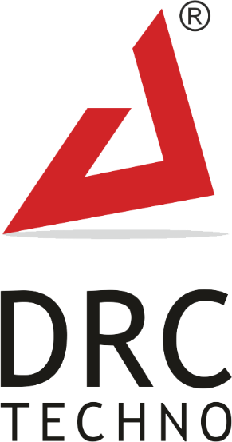

Contact : +91 990 9990 867 | Skype : Support.drctechno | Email ID : support@drctechno.com
Plot No. 294, Ground Floor, Beside Dharmanandan Diamond, Gotalawadi, Katargam,
Surat – 395004, Gujarat - INDIA

